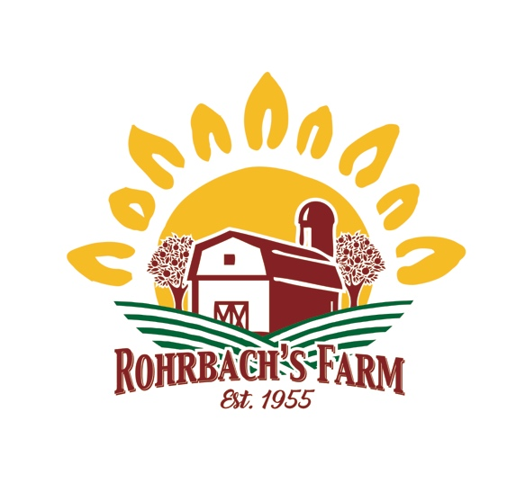
Summer Rental
Pavilions & Outdoor Space
(late April – Labor Day)
To make a reservation:

- Call or email to reserve a date and time; 570-356-7654 or rohrbachs.farm.market@gmail.com.
- Submit a signed Renter Agreement, Liability Waiver and Compliance Form (Page 2), along with a reservation deposit within ten days after reserving date and time.
- Send a deposit of $25.00. This is required for all reservations.
Additional information:

- Our private open-air pavilion is a great place to gather for food and fun! Plenty of yard space for games! This event space is recommended for up to 50 guests.
- ​All rentals are available starting at 9:00 am and must be vacated by 9:00 pm.
- Rental fee is $75/ Hour; for a minimum of three hours.
- Renter is responsible for and required to have outdoor restrooms, minimum one and a hand washing station. Rohrbach's Farm will make the reservation and will add only the cost of the rental (there is no upcharge) of outdoor restrooms to the rental total. ​
- Pavilion rental includes; covered pavilion, picnic tables, trash service, and electricity.
- Fire Pit rental is an additional $50. Roasting sticks provided upon request.
- Renter is permitted to bring your own food and non alcoholic beverages. We do have deli trays, beverages, and desserts available from our farm market. Big Dan’s BBQ is our preferred caterer. External caterers must provide proof of ServSafe certification, insurance and retail food licensing.
- The only alcoholic beverages permitted are wines purchased by the bottle from Freas Farm Winery. This is in compliance with state and local liquor laws.
- Notification of cancellation must be submitted in writing 7 days before the scheduled event date. Reservation deposit will not be refunded for any cancelations.
- Balance for the event is due on the date of the scheduled event.
- No Sunday rentals available.
- Friendly pets, on a leash, are welcome outside. However please clean up any messes!
- Please make sure that guests do not drive on the grass and park only in designated areas.
- Guests provide: table coverings, paper goods, food. Table Covers are recommended. You are permitted to decorate; however, no nails or holes may be put into the pavilions. ​
Renter will need to supply the following:

- Tablecloths | - Paper products
- Decorations
Rohrbach’s will supply:

- Tables and benches for seating | - Table space for food and gift
- Trash and Recycling Cans and Removal | - Outdoor restrooms and handwashing

Renter Agreement, Liability Waiver & Compliance Form:

Renter’s Information: Summer Pavilion Rental
Name:
Email:
Mailing Address:
Phone #:
Alternate Phone #:
Reservation Date:
Reservation Times:
Signed Agreement & Deposit Due:

- Renter understands that NO alcoholic beverages or drugs are permitted on property with the exception of wine purchased from Freas Farm Winery
- Renter agrees that the noise level will be kept to a minimum.
- Renter agrees that the property will be returned to the original condition.
- Renter understands that they are renting a semi-private space, use of tables, seating and designated area.
- Renter has read and understands the list of items recommended to bring and the list of items Rohrbach’s will supply.
- Renter agrees notification of cancellation must be submitted in writing 7 days before the scheduled event date and the reservation deposit will not be refunded.
- Renter agrees to ensure parking only in designated areas.
- Renter understands the rental fee and additional fees. Renter agrees they will be charged for additional hour(s) if they do not abide by their reservation time.
- Renter acknowledges receipt of this agreement and recognizes signing this agreement is a waiver and release and expressly agrees to release and discharge Rohrbach’s Farm Market and all of its affiliates, managers, staff, and representatives from any and all claims or causes of action and agrees to voluntarily give up or waive any right to bring a legal action against above stated for personal injury or property damage.
- Renter agrees to be held responsible for any and all costs in the event that any damage to facilities occurs as a result of willful, reckless or neglectful action.

Violators of any part of this agreement will be asked to leave the property immediately without any refund.

I, ___________________________________________ (Renter) have read and agree to the above requirements.
Signed Rental Agreement and $25 deposit can be dropped off during business hours or mailed within ten days to: Rohrbach’s Farm Market 240 Southern Drive; Catawissa, PA 17820

